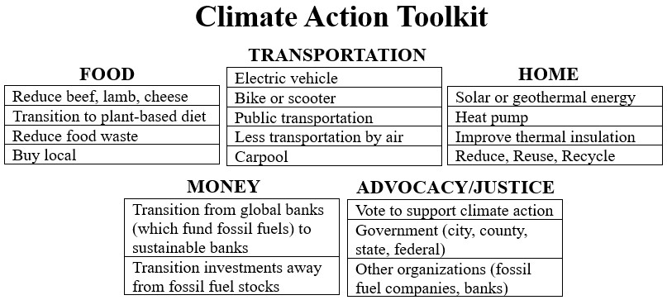

Climate Action Step #1
What will I do?

By when?

Who or what can help me?

Climate Action Step #2
What will I do?

By when?

Who or what can help me?

